an addendum

Report of the
auditor-general
on the accounts of Gombe state government as regards COVID-19

budget implementation
report for the year ended 31st DECEMBER, 2020

audit certificate
on covid-19 budget performance for the year ended 31st december, 2020

The budget execution reports of the Government of Gombe State of Nigeria for year ended 31st December, 2020 on the COVID -19 related funds had been submitted to me. The report have been audited by me in accordance with Section 125 Sub-section 2 of the Constitution of the Federal Republic of Nigeria 1999 (as amended) and the Gombe State Audit Law 2018 Section 4(a).
In the course of the audit, I performed financial compliance audit in accordance with International Standards on Auditing (ISAs) and International Standards of Supreme Audit Institutions (“ISSALs”). I have obtained information and explanation that to the best of my knowledge was relevant and necessary for the purposes of the audit. This audit has provided me with reasonable evidences and assurances which formed the basis for my independent opinion.
In my opinion, the reports on the related COVID-19 budget implementation by Gombe State, presents fairly and completely, in all material respects, expenditures incurred against the COVID-19 recovery Program by the State for the year ended 31st December, 2020, in line with International Public Sector Accounting Standards (IPSAS) and the Applicable Laws and Regulations.
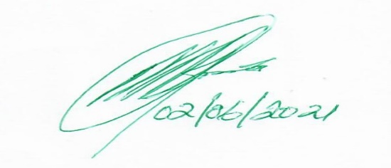

MUHAMMAD BUBA G. (FCNA)
AUDITOR-GENERAL
GOMBE STATE

DISCLOSURE IN THE GOMBE STATE AUDITED FINANCIAL STATEMENT FOR THE YEAR ENDED 31ST DECEMBER, 2020 ON COVID 19 BUDGET AND EXPENDITURE.

Gombe State Government has made a Covid Revised budget of One Hundred and Seven Billion, Six Hundred and Nine Million, Three Hundred and Eight Thousand, Five Hundred and Ninety Three Naira, Forty Eighty Kobo (N107, 609,308,593.48) only, for the year ended 31st December, 2020 and tagged 15.60 % as Covid 19 budget of Sixteen Billion, Seven Hundred Eighty Six Million, Five Hundred Thousand Naira (N16,786,500,000.00) only due to the importance of Covid 19 management in the State. Find here an addendum to the Audit Report on the Accounts of Gombe State Government for the year ended 31st December, 2020 as regards to the Audited Covid 19 Budget Implementation Report by Economic Classification for the year ended 31st December, 2020 as detailed in various economic codes showed below.

The analysis of the above table revealed that a total sum of Sixteen Billion Seven Hundred and Eighty Six Million, Five Hundred Thousand Naira (N16,786,500,000.00) was budgeted and tagged as Covid 19 budget expenditure which represent 15.60% of the total State revised budget. It was further revealed that out of this budget figure; the State expended on Covid 19 related matters the total sum of Nine Billion, Two Hundred and Ten Million, Five Hundred and Seventy Thousand Five Hundred and Seventy Nine Naira Nine Kobo Nine Billion, Two Hundred and Ten Million, Five Hundred and Seventy Thousand, Five Hundred and Seventy Nine Naira, Nine Kobo (N9,210,570,579.09) only, representing 54.87% of the Covid 19 tagged budget, leaving a budget surplus of Seven Billion Five Hundred and Eighty Million Nine Hundred and Twenty Nine Thousand Four Hundred and Twenty Three Naira (N7,580,929,423.91) only. This represent 54.87% of the Covid 19 tagged budget. The Budget Performance on Covid 19 expenditure is commendable.

